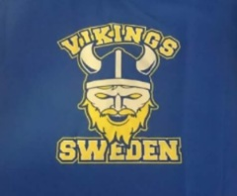
MALMÖ, Sweden, Airline Industry Ice Hockey Tourney April 2nd – 6th 2019!
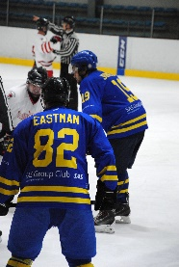
And you are invited!
8 teams Tourney
I´m glad to inform you that once again I will host a tournament in Sweden.
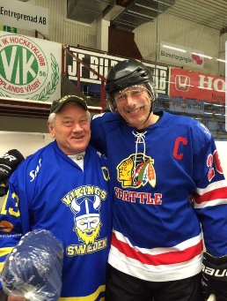
This time it will be held in the beautiful city of Malmö, in the very south of Sweden and very close to the capital of Denmark, Copenhagen.
Malmö is just 20 min by train from CPH airport and 28 min from downtown Copenhagen

What will be included in this tournament!?
Hotel for 4 nights at Park Inn Malmö (2 min walk from ice arena and 10 min walk from downtown Malmö and train station)
Daily breakfast
Welcome dinner buffet incl drinks on Tuesday April 2nd
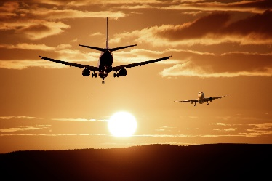
Lunch at the hockey arena Wen-Fri
Minimum 5 games / team
All equipment can be stored at the ice arena
Pool area and sauna at the ice arena
Refreshments at the ice arena
Transportation for all your hockey equipment and bags from CPH airport
T-shirts for all guests
Farewell party incl dinner and drinks on Friday April 5th
Trophies for all teams, size depends on your skills
Nice prices for the player of the game
Bookable Ice time on Tuesday April 2nd between 11am – 4pm for warm up or pre games
Extra nights at the hotel with good discount can be arranged
What will this party cost!?
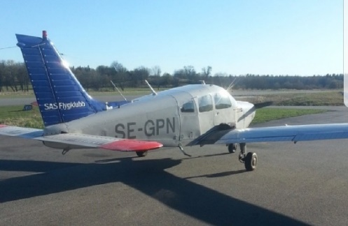
Team Fee 6000 SEK
Twin or double room 5500 SEK / player
Guests in twin or double room 5200 SEK / Guest
First kid in twin or double room half price(on guest price), 2nd kid in extra bed 500 SEK
Sounds good, right!?! But it will be better
Since I have started a new company I´ll give everyone that follow and like me on Instagram, Facebook and Twitter and pre book and deposit no later then 1st September 2018 500 SEK discount / adult

Rules:
2x20 running time with stop time during power/boxplay
Stop time last 3 min if no more than 2 goals difference
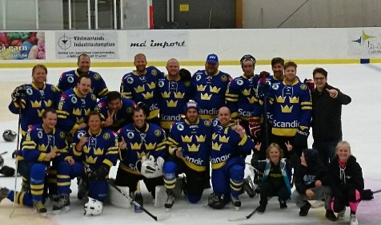
Final games on Friday stop time and hopefully 15 min break between periods
Time out is allowed 1 / team / game
Slapshots are allowed, body checks are not!
No fighting
Icing rules are set by the team captains at captains meeting

Since this is an 8 teams only tourney, make sure to pre book your spot asap so you don´t miss all the fun.

Patrik Jernberg
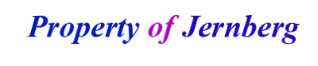
https://www.facebook.com/propertyofjernberg.se
https://www.instagram.com/propertyofjernberg.se
https://twitter.com/propofjernberg

