THIS IS THE BIGGEST 4 ON 4 ICE HOCKEY ADVENTURE OF YOUR LIFE
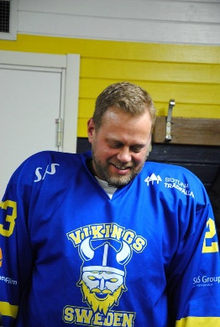
Welcome to the mythical Capital of Greece, ATHENS
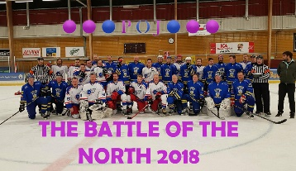
I hereby invite you to my new adventure on ice in Athens, Greece
September 23-29th 2019!

This adventure tournament will take place on the 1000sq.m ice in Ice Heart arena in Athens.
And you will be staying 45min west of the Capital at a place called Kinetta Beach Resort & Spa where I can offer you ALL INCLUSIVE** eat and drink buffet style Breakfast, Lunch, Dinner, Drinks, Snacks, Pools, Beach and Sports Everyday.
This is a 6 team adventure tournament only and 1 spot have already been taken by the
Greece Former National Ice Hockey Team, ALL STARS OF GREECE
So hurry up or be out!
6 teams fighting for the big trophy over minimum 3 games / team over 2 days.
So here is what will be incl in your package:
- 6 Nights at Kinetta Beach Resort & Spa with ALL INCLUSIVE**
- Transfer from Resort-Ice arena-Resort
- Free T-shirt or towel and water bottle for each player and guest
- Refreshments and snacks at the ice arena
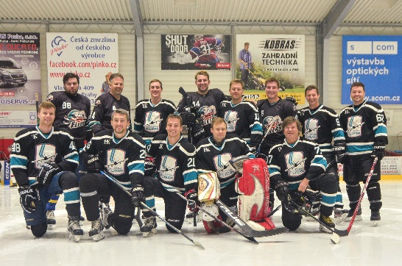
- Exclusive prices to winning team and MVP´s
- Beach tournaments
- And plenty more to come
Sounds good? Guess so!

So what will this adventure tournament cost?
For all above and plenty more the price is only 900EUR / player or guest.
Want to bring your family? No problem at all! Family prices for kids can be arranged!
Want to stay longer or get there earlier? No Problem if you let me know in time, I can arrange good deals on the resort with ALL INCLUSIVE**

The only thing you need to do right now to confirm your spot is to send a mail to
jernbergpatrik@hotmail.com
and make a first deposit by end of September 2018

Rules and game schedule
Games will be played Tuesday and Wednesday September 24th- 25th from 9am – 3pm
2 groups, Crossover semifinals between 1st and 2nd place in groups
3 place Vs each other, minimum 3 games / team
Game time is set to 2x20min running time with stoptime last 5min if no more then 2 goals difference.
Slap shots are allowed
No body checks and No Fighting
Icing rules are the same as international rules
Didn´t win the Hockey? Want another chance to go home with a Trophy??
Soccer tournament will be played on request on Thursday September 26th At the resort, Game time 2x15min,
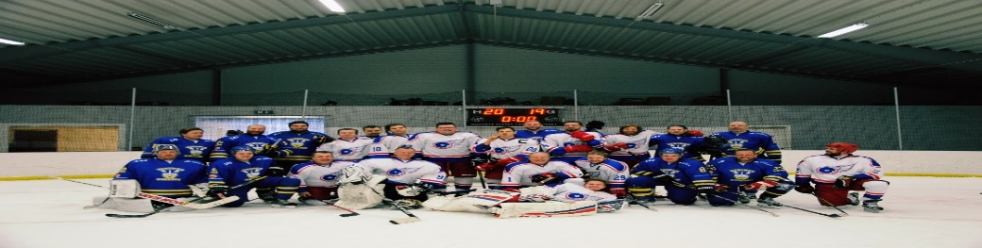
________________________________________________________
ALL INCLUSIVE** ALL DAY AT THE RESORT
Breakfast – Lunch – Dinner: with water, wine in the main restaurant.

10:30 – 18:00 snack bar:
refreshments in post mix, orange juice, coffee, tea, camomile, draught beer, ouzo, gin, vodka, rum (alcoholic from 11:00).
12h00 – 13h00 snack (different each day)
16h00 – 17h30 cakes and scones.

18h00 – 23h30 main bar: refreshments in post mix, orange juice, coffee, tea, camomile, draught beer, ouzo, gin, vodka, rum, whiskey, wine.

10:00 – 18:00 pool bar: soft drinks, orange juice, draft beer

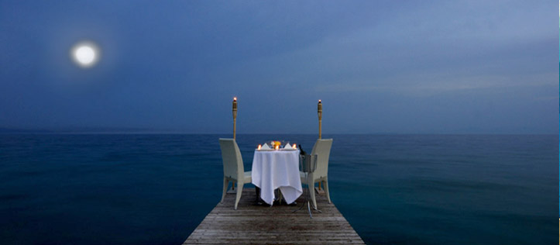
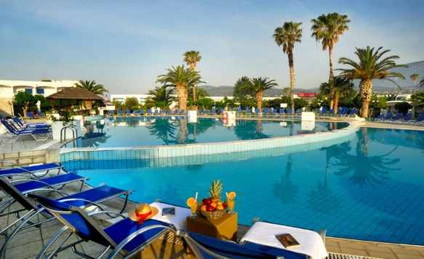
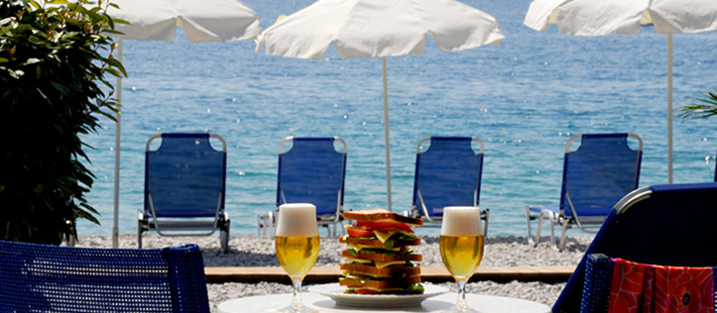
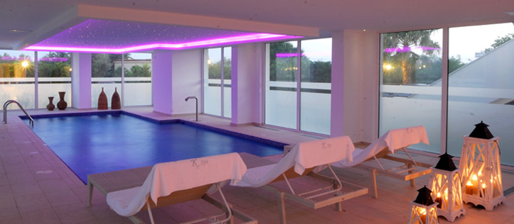
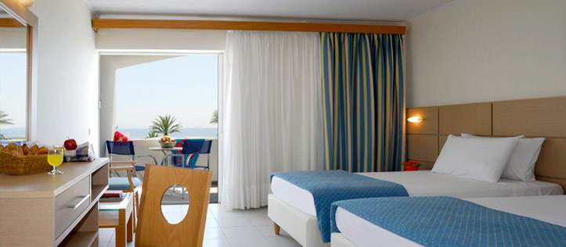
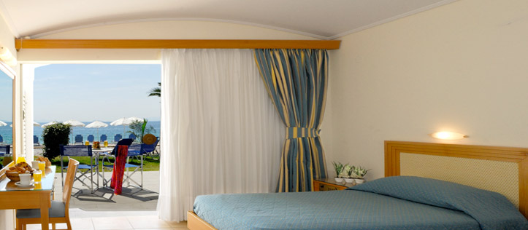
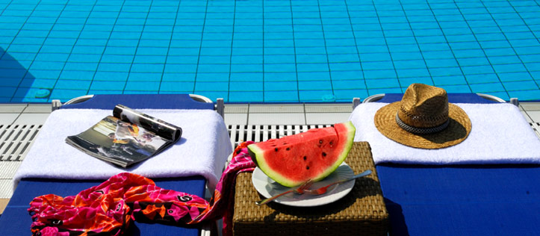
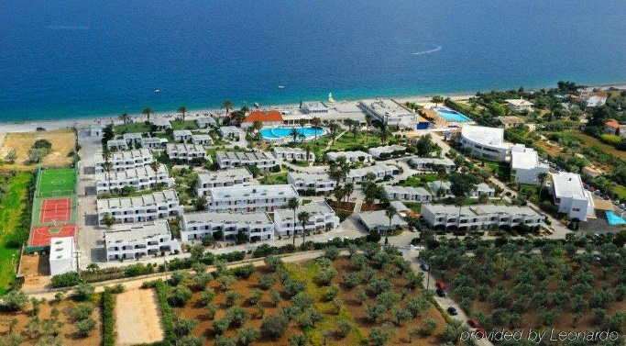
10:00 – 18:00 beach bar: soft drinks, orange juice, coffee, draught beer, ouzo

