Do you have any clue how to start up the 2019/2020 Ice hockey season yet?
Now you have!
Property Of Jernberg is proud to let you know that we have a perfect start up for your hockey season 2019/2020
It´s time for the yearly Hamburger Cup in Hamburg Germany!
The date for this 5 teams tournament is set to August 20-24 2019

So what is this Hamburger Cup in Hamburg Germany then?!
This tournament is a 5 teams tournament only. If you end up 1st place you are in the final, 2-3 place you will be in the play off to the final, 4-5 place you will play against each other for those places. The games will be played at the Volksbanksarena from 8am – 5.30pm on both Wednesday and Thursday August 21-22 and from 8am – 1.30pm on Friday.
The game time is set to 2x20 stop time with 15min brake between periods and the rules are like always, No body checks, No fighting and Slapshots are allowed and icing rules are set by Team Captains at the Captains Meeting. It´s Recreations Ice Hockey!
What will be included in this tournament!?
4 nights on Park Hotel Hamburg Arena, daily breakfast, Buffet lunch Wed-Fri at the ice arena, A welcome party with BBQ dinner and drinks, 5 games / team and you can leave your equipment at the ice arena from Tuesday until Friday, snacks and drinks in the locker rooms, very good prices to the MVP, priceaward party with dinner and drinks on Friday August 23, a lot of fun and much much more

What is the price for all this fun!?
The price for this fun event is only 510EUR / Player
and a team fee of 610EUR
Sounds good? Guess so!
So the only thing you need to do now is to send a mail to
jernbergpatrik@hotmail.com
and confirm your participation in
HAMBURGER CUP IN HAMBURG GERMANY
https://www.facebook.com/propertyofjernberg.se

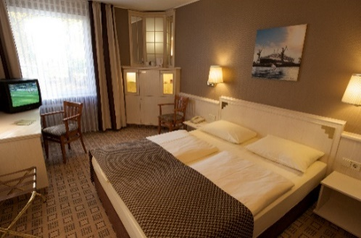
https://www.instagram.com/propertyofjernberg.se
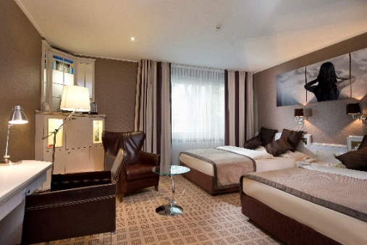

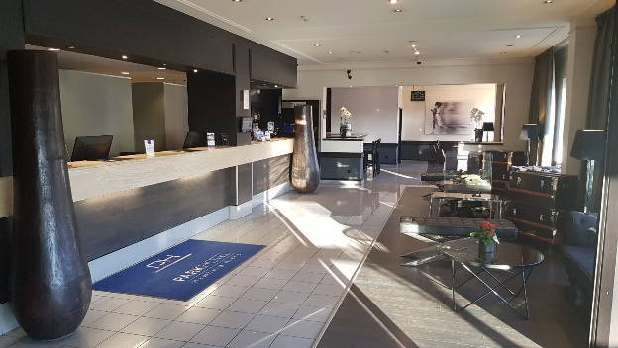
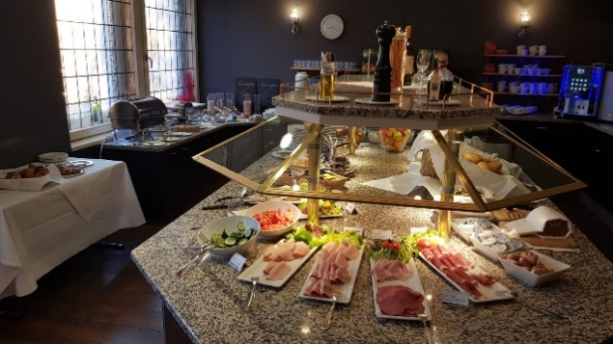
Hockey For Fun by
